3.3.2 (p. 145) Exhibit a maximum matching in the graph below, and use a result in this section to give a short proof that it has no larger matching.

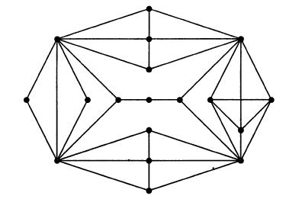

4.1.5 (p. 158) Let G be a connected graph with at least three vertices. Form G’ from G by adding an edge with endpoints $x\text{,} y$ whenever $d_{G}\left(x,y\right)=2$. Prove that G’ is 2-connected.

4.2.1 (p. 172) Determine $κ\left(u,v\right)$ and $κ'(u,v)$ in the graph drawn below. (Hint: Use the dual problems to give short proofs of optimality.)

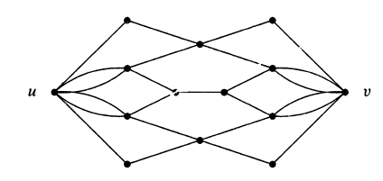

4.3.3 (p. 188) A kitchen sink draws water from two tanks according to the network of pipes with capacities per unit time shown below. Find the maximum flow. Prove that your answer is optimal by using the dual problem, and explain why this proves optimality.

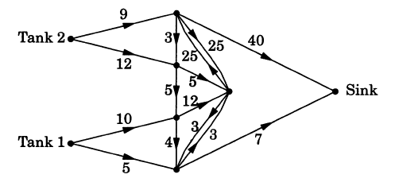

5.1.12 (p. 200) Prove or disprove: Every *k*-chromatic graph *G* has a proper *k*-coloring in which some color class has $α(G)$ vertices.

5.3.4 (p. 229)

a) Prove that $χ\left(C_{n};k\right)={\left(k-1\right)}^{n}+{\left(-1\right)}^{n}\left(k-1\right).$

b) For $H=G∨K_{1}$, prove that $χ\left(F;k\right)=kχ(G;k-1)$. From this and part (a), find the chromatic polynomial of the wheel $C_{n}∨K_{1}$.